Sri Lanka Institute of Information

Technology

Lab Submission

09

**IT24100647**

**A.J.M.P.N.Jayasekara**

**Probability and Statistics | IT2120**

B.Sc. (Hons) in Information Technology

**Exercise**

1. Assume that the time taken to bake a batch of cookies is normally distributed with mean 45 minutes and standard deviation 2 minutes.

i. Generate a random sample of size 25 for the baking time.

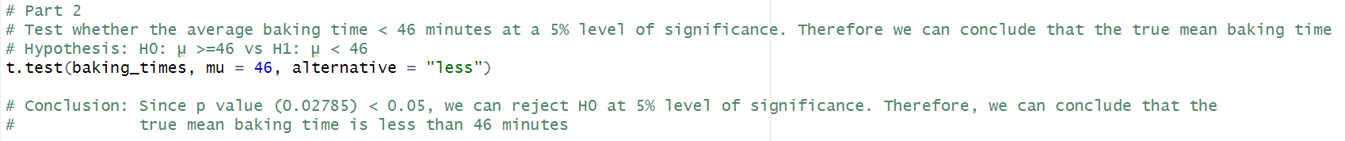ii. Test whether the average baking time is less than 46 minutes at a 5% level of significance.

